Comprehensive Project Report: Student Attendance & Exam Eligibility Analysis Using Power BI

5.1 Introduction
Student attendance and fee clearance are two major criteria for determining eligibility to appear for academic examinations. Traditionally, this verification process is handled manually using spreadsheets or paper records, which is time-consuming and prone to errors.
The purpose of this project is to build a data-driven, automated, and visually interactive system using Power BI to determine exam eligibility based on:
- Number of days present
- Fee payment status
- Attendance percentage
This project demonstrates the ability to work with databases (MySQL), perform data transformation (Power Query), build meaningful calculated fields (DAX), and create clean, interactive dashboards using Power BI.

5.2 Tools and Technologies Used
Tool | Purpose
MySQL | Source of raw student data
Excel | Used as intermediate export/import file
Power BI Desktop | Main tool for modeling and visualization
Power Query Editor | For data transformation and cleaning
DAX (Data Analysis Expressions) | For creating dynamic calculated measures
M Language | Custom column logic in Power Query

5.3 Project Data Flow
Step 1 → Data Extraction
- Student records were originally stored in a MySQL database.
- A SELECT query was used to export student details into Excel (.xlsx format).

Step 2 → Data Loading
- The Excel file was imported into Power BI Desktop.
- The dataset included:
  - Register Number
  - First Name
  - Last Name
  - No. of Days Present
  - Fees Status
Step 3 → Transformation (Power Query)
- The data was cleaned, merged, and new columns were created.
- This ensures all required transformations are done before the data enters the model.
Step 4 → Modeling & DAX
- A DAX measure was created to compute attendance percentage based on total working days = 220.
Step 5 → Visualization
- An interactive dashboard was built to show:
  - Attendance %
  - Eligibility Status
  - Total Present Days
  - Fees Status
  - Student Identity

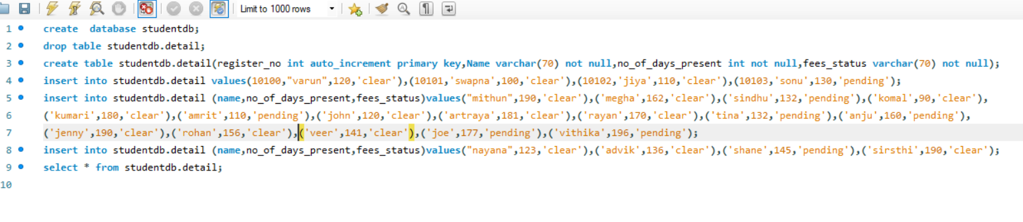
Screenshot of table created in mysql

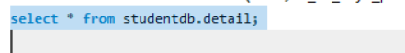
Screenshot of selecting table to export table in excel

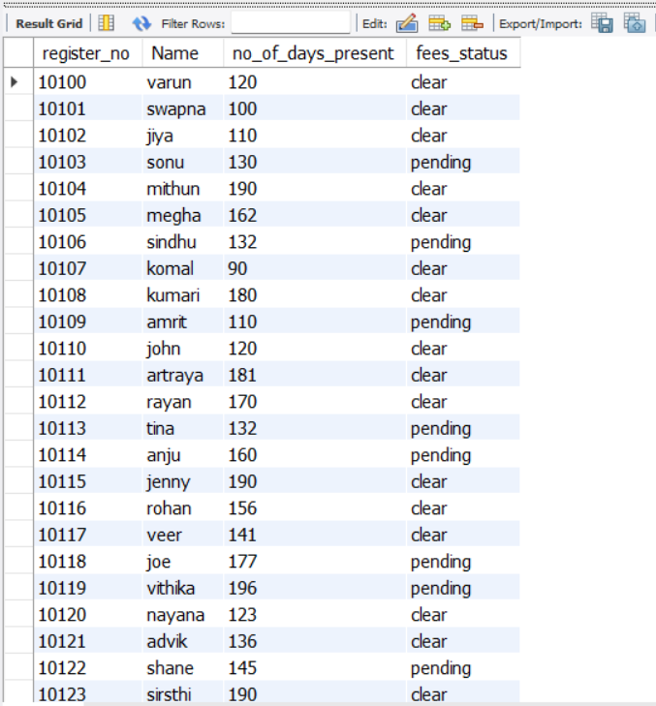

Screenshot of data table to be exported to excel
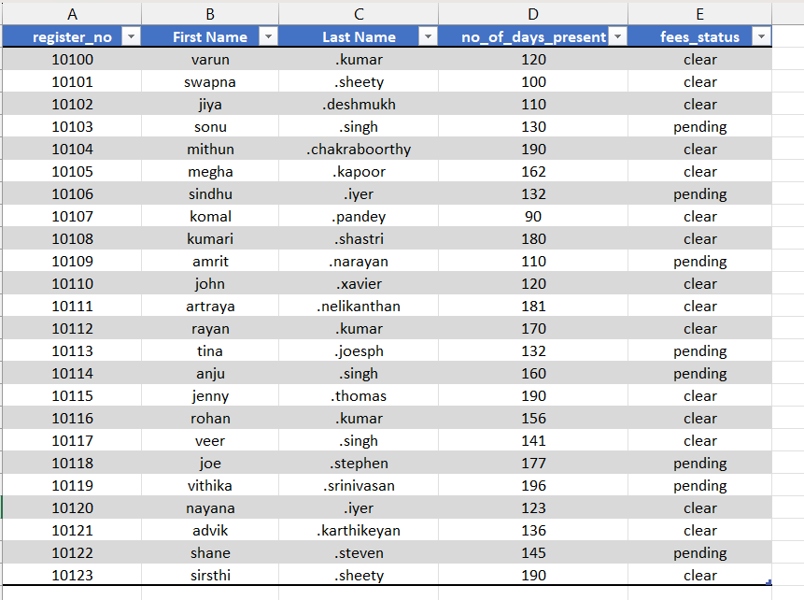
Screenshot mysql table exported in excel and added new column named last name

5.4 Detailed Data Transformation (Power Query)
This is the heart of your project. Here is a very detailed explanation of EVERY transformation you performed:
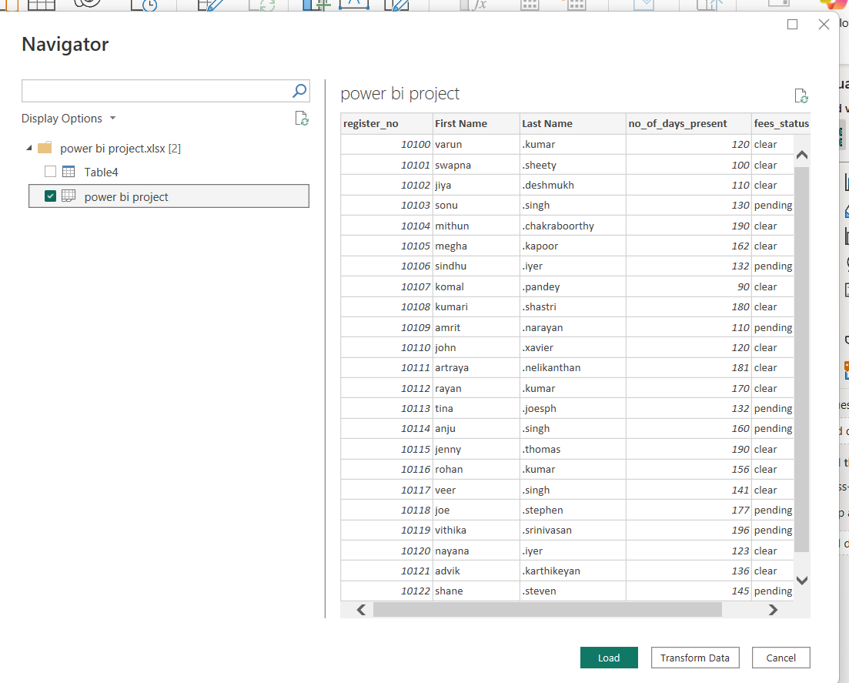
Screenshot of transforming data in power bi

5.4.1 Removing Unnecessary Spaces & Cleaning Data
- Applied Trim to remove leading/trailing spaces from names.
- Applied Clean to remove unprintable characters from text.
Reason:
This ensures consistency across the dataset, especially when using conditional logic

5.4.2 Changing Column Types
- register_no → Whole Number
- no_of_days_present → Whole Number
- fees_status → Text
Reason:
Correct data types ensure smooth calculations and prevent errors in DAX and visuals.

5.4.3 Merging First Name & Last Name
Using Home → Merge Columns:
- Selected First Name and Last Name
- Chose space (“ ”) separator
- Renamed the new column to Full Name
Why this is important:
Reports look cleaner, and searching for students becomes easier.

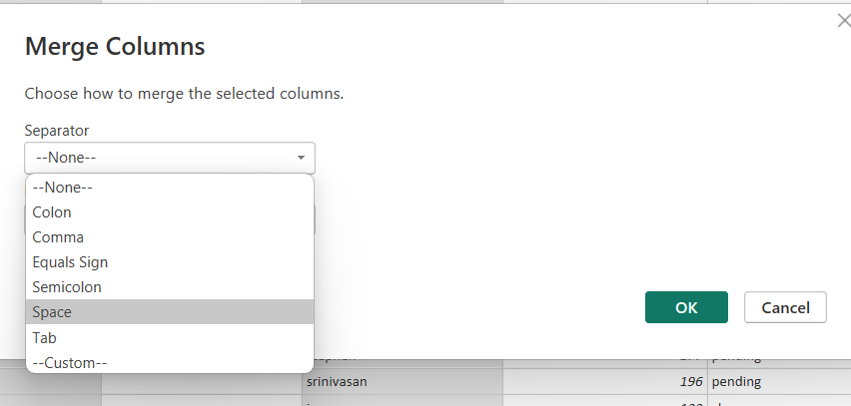

Screenshot of merging last name and first name column

5.4.4 Creating Exam Eligibility Column (Custom Logic)
A custom column was created using Power Query M code:
if [no_of_days_present] > 120 and ([fees_status]) = "clear" then "Permitted"
else "Not Permitted"

Logic Explanation (Very Detailed):
- Attendance Threshold
  - Students must attend more than 120 days to be considered regular.
  - This number was derived from academic policy (example for project).
- Fees Status
  - Only students who have cleared fees are eligible.
- AND Condition
  - Both conditions must be satisfied simultaneously.
- Output Values
  - "Permitted" → Eligible for exam
  - "Not Permitted" → Not eligible
- Case Normalization
  - Text.Lower() ensures that “Clear”, “clear”, “CLEAR” all behave the same.
This transformation is very important because it implements business logic inside the data
preparation layer.

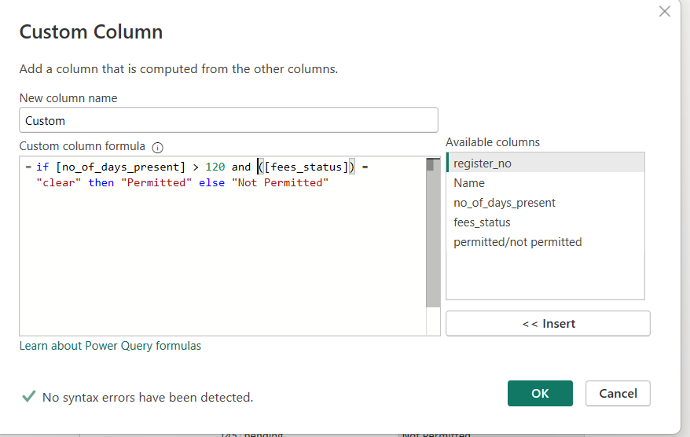

Screenshot of creating condition for column

5.5. DAX Modelling (Data Analysis Expressions)
After loading the clean data to the model, DAX was used to compute Attendance Percentage.

5.5.1 Attendance Percentage Calculation
DAX Calculations (Inside Power BI Model)
After closing Power Query → Apply changes → Go to Model View or Data View.
Total working days = 220
Created a new DAX column:
Attendance % =student report [no_of_days_present] / 220
What this does?5.
- Converts attendance count into percentage.
- Used later to visualize attendance performance.
You can also format it as %.

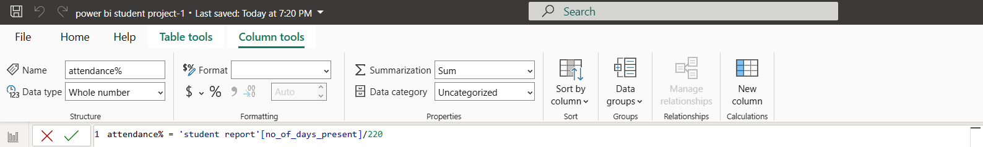

Screenshot of using DAX to calculate attendance percentage

5.6 Visualizations (Dashboard)
Power BI visuals used:

5.6.1 Table Visual
A table visual was created with the following columns:
- Register Number
- Student Name (merged field)
- No. of Days Present
- Attendance %
- Fee Status
- Exam Permission Status
Purpose
- Displays a complete structured view of each student.
- Easy to compare attendance and exam eligibility.
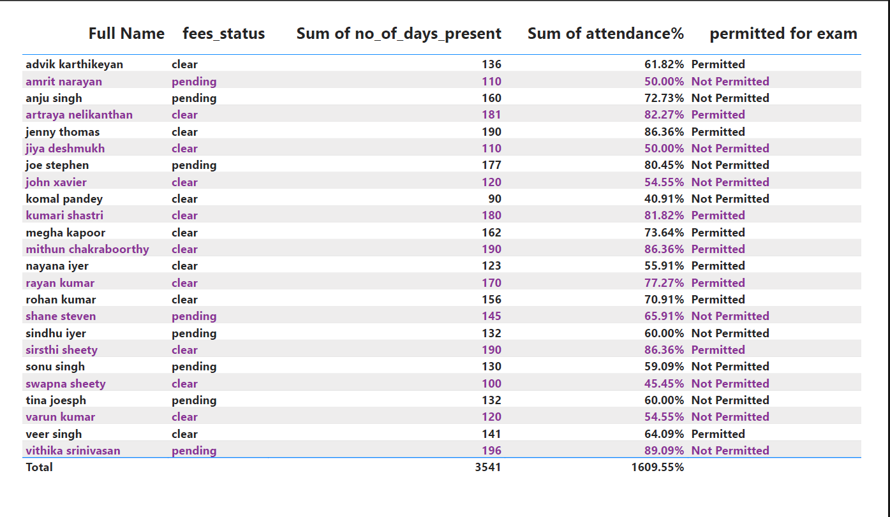Screenshot of table visualization in power bi
5.6.2 Tree Map Visual
Tree Map Fields:
- Group: Exam Permission (Permitted / Not Permitted)
- Values: Register No (Count)
Purpose
- Shows overall distribution of eligible vs not eligible students.
- Helpful for quick performance insights (ex: “How many students are permitted?”
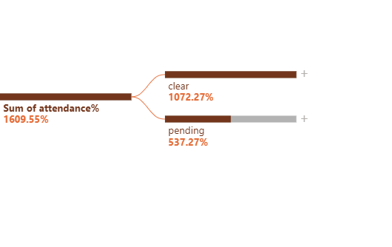
Screenshot of visualization based on attendance% analyse

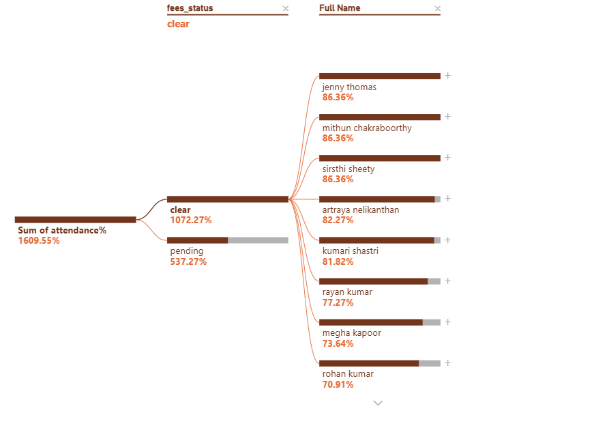
Screenshot visualization based on fees status and full nam
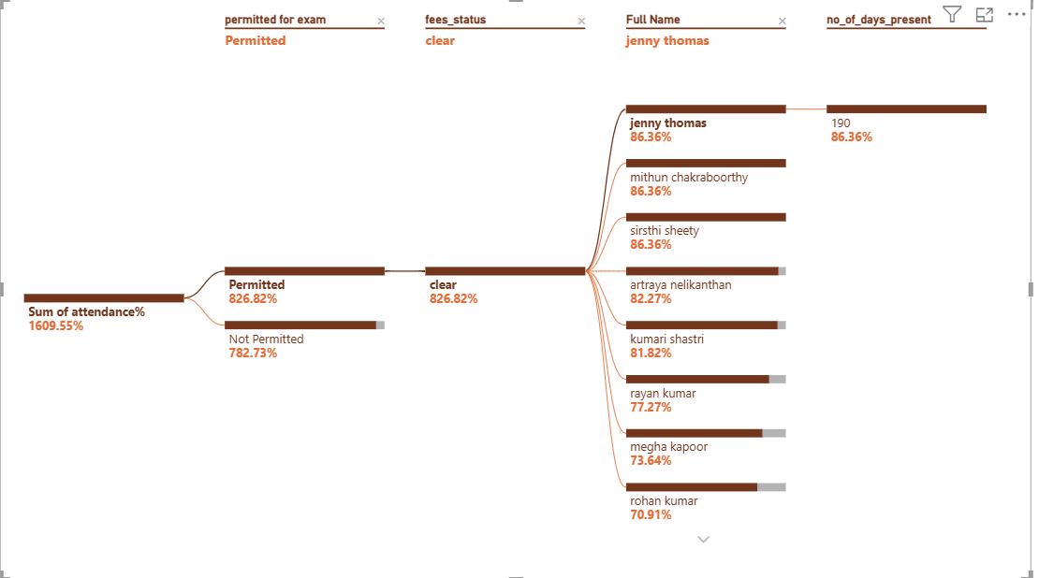

Screenshot of visualizing based on attendance%, permitted for exam, fees status, full name ,no of days present

5.7 Final Insights Derived
5.7.1 Attendance Compliance
- Students with attendance above 120 days show higher eligibility.
- Attendance percentage helps identify borderline cases.
5.7.2 Fee Clearance Impact
- Students having sufficient attendance but “pending” fees are not permitted.
- Helps management follow up with only pending-fee students.
5.7.3 Combined Exam Eligibility
The custom column clearly shows:
- Permitted students
- Not Permitted students, and why (either low attendance or fee pending)

5.8 Conclusion
Through Power BI:
- The data was cleaned, merged, transformed, and enriched with new fields.
- DAX calculations helped convert raw numbers into meaningful performance metrics.
- Visualizations made the insights easily understandable.
- The project effectively identifies students who can write the exam based on attendance and fee status.

